Tutorial Three

Building a Neural Network for MNIST Handwritten Digit Classification

Prepared By:
Muhammad Anees
537630

Assigned By:
Dr. Shahbaz Khan

.



NATIONAL UNIVERSITY OF SCIENCE AND TECHNOLOGY
SCHOOL OF MECHANICAL AND MANUFACTURING ENGINEERING
Tasks:
- Experiment with Different Architectures
Modify the neural network architecture to see how it affects model performance.
Add more layers or change the number of neurons in each layer.
Experiment with different activation functions such as tanh or sigmoid.
Compare the performance of the modified model with the original model.
  - Compare Different Optimizers
Test different optimizers to see how they impact training and convergence.
Train the model with different optimizers such as SGD, RMSprop, and Adam.
Compare training speed and final accuracy of each optimizer.
  - Observe and interpret the training and validation accuracy and loss curves.
Identify whether the model is overfitting, underfitting, or well-fitted by comparing the curves.
Observe the effect of changing the number of epochs on overfitting and underfitting.
Implement Early Stopping
Experiment with Regularization Techniques

Results:
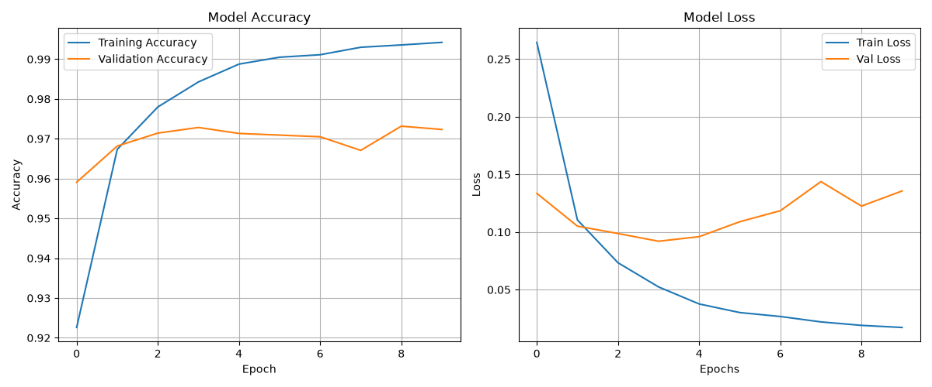
By Running the code as it is, the results were as follows:

By changing
Activation = relu
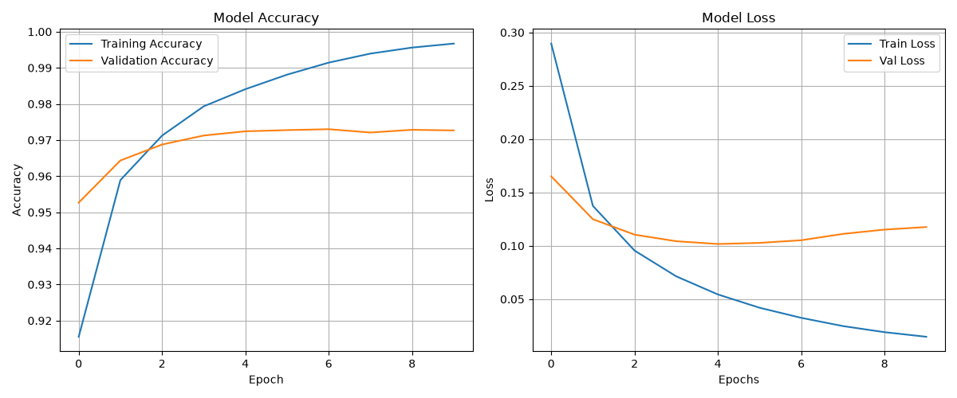
Optimizer = RMSprop

Activation = relu
Optimizer = Adam
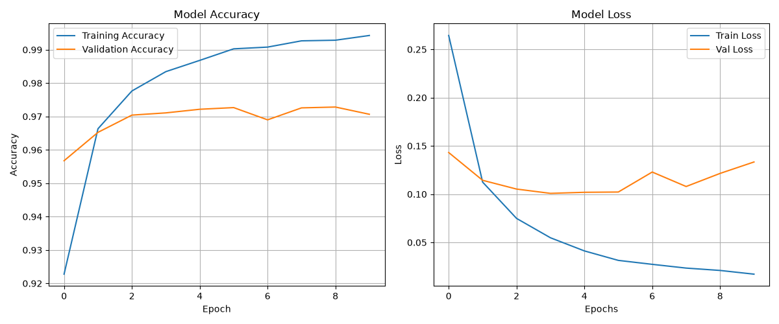

Activation = relu
Optimizer = SGD
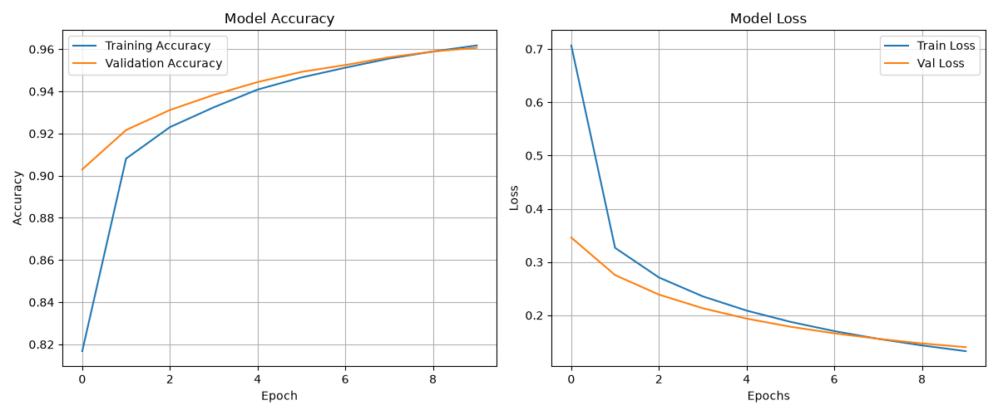

Activation = sigmoid
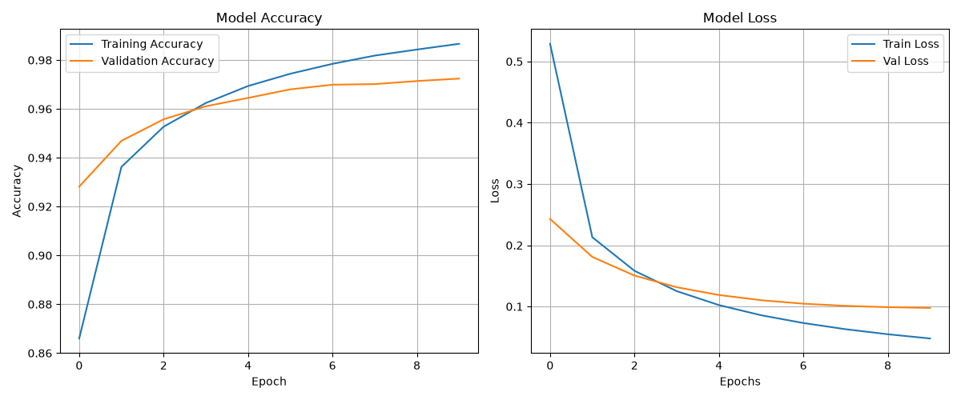
Optimizer = RMSprop

Activation = sigmoid
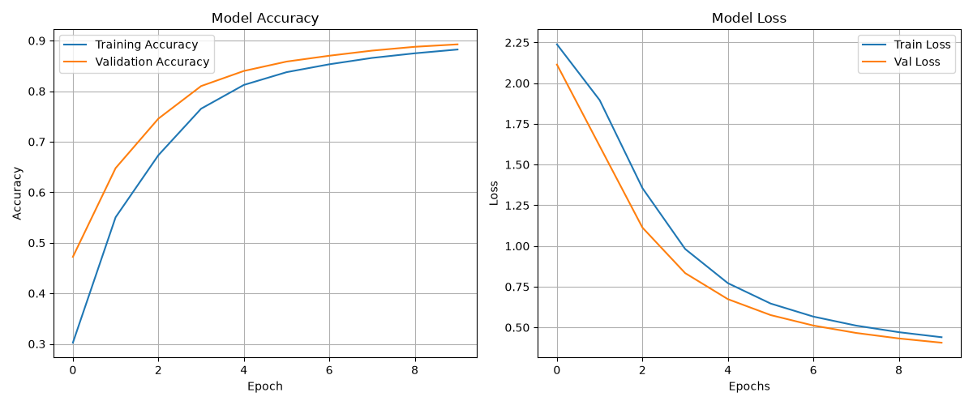
Optimizer = SGD

Activation = sigmoid
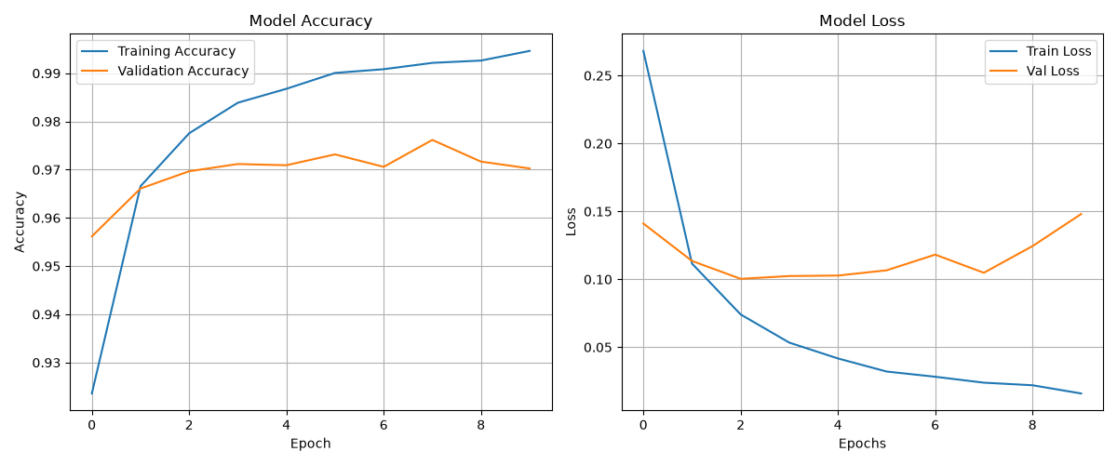
Optimizer = Adam

Activation = relu
Optimizer = SGD
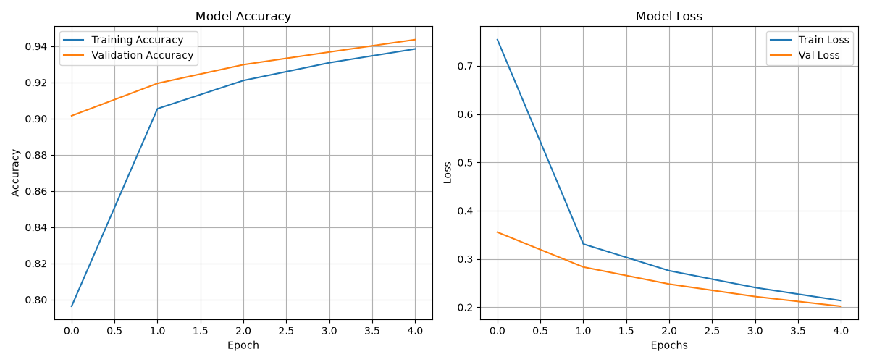
Epochs = 5

Activation = relu
Optimizer = SGD
Epochs = 10

Activation = relu
Optimizer = SGD
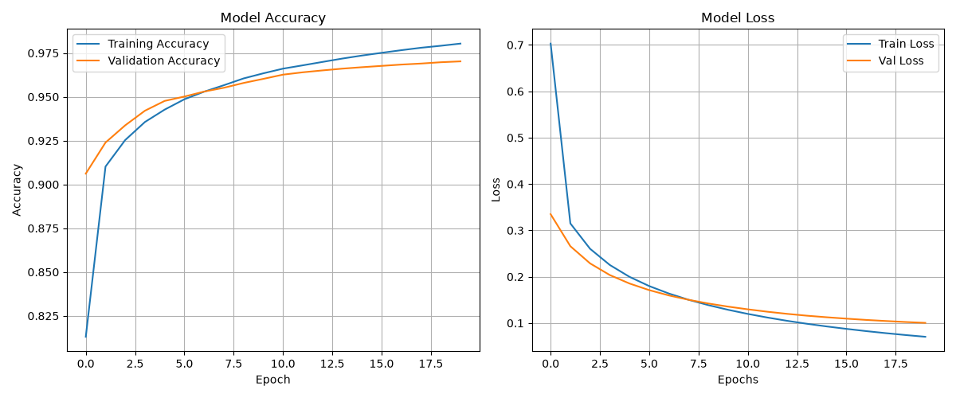
Epochs = 20

Activation = relu
Optimizer = SGD
Epochs = 10
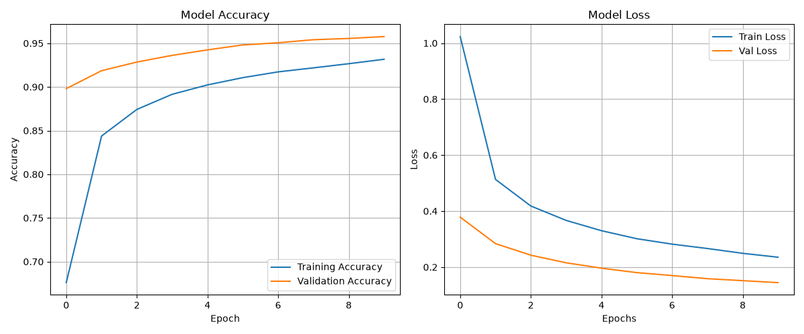
Dropout = after first layer 0.4, after second layer 0.2

